1. What is Messaging?
   1. Messaging is the process of exchanging business data or information across applications or the components within the same app.
2. The Key components that make up a messaging system are
3. 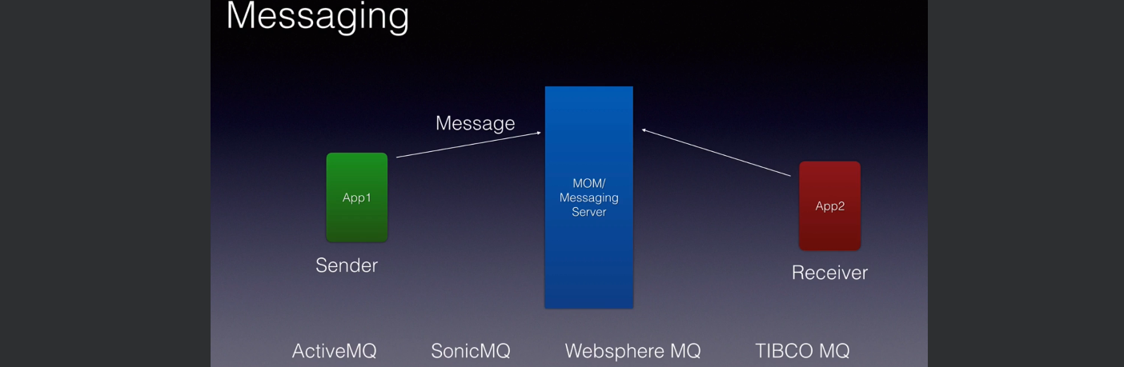
   1. **Sender**:
      1. The app that sends the msgs is called **Sender**.
   2. **Receiver**:
      1. The app that receives the msgs is called **Receiver**.
   3. **Message**:
      1. It has business data or info.
      2. Also includes networking or routing headers.
   4. **MOM**: **M**essage **O**riented **M**iddleware.
      1. It is messaging server.
      2. **Responsibility**:
         1. To take the incoming msg.
         2. To make sure its delivery to an appropriate receiver.
      3. It also providers various services or advantages such as
         1. Fault Tolerance.
         2. Load Balancing.
         3. Scalability.
         4. Transaction Management.
         5. And Many More that we will learn.
   5. **Some examples** for MOM (Message Oriented Middleware) are
      1. ActiveMQ.
      2. SonicMQ.
      3. Websphere MQ.
      4. Tibco MQ.
4. Let’s take an example:
5. Suppose, we are building a **Check Processing App**.
6. We can split it into two components.  
   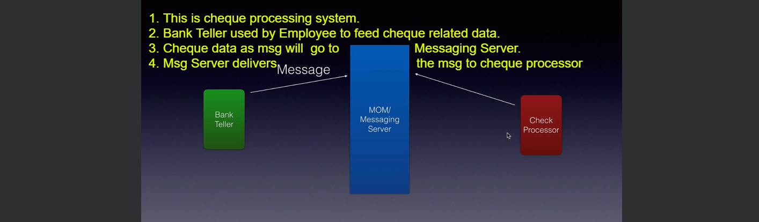
   1. Bank Teller App:
      1. Used by Bank Employee.
      2. Employees will take cheques from customers and put the data into Bank Teller app.
      3. Bank Teller App will send the cheque as msg to Messaging Server.
   2. Check Processor:
      1. This app will receive the msgs from Messaging Server and will process it.
   3. MOM/Messaging Server:
      1. Message Broker.
      2. It decouples the sender and receiver.  
         As tomorrow, if we want to use a different cheque processing app, we can simply get rid of existing one and can use new one.